REFERENCE ENTRY INSTRUCTIONS

Table of Contents
US Patent/Publication References | 2
Foreign Patent/Publication References | 3
US Prosecution Documents | 4
Foreign Prosecution Documents | 8
US Unpublished or Provisional Applications | 15
Web Pages as References | 16
Journal Articles and other scholarly work | 17
Books | 18
Court Document | 19
Video | 20
Overview of Marking references | 21

These instructions attempt to cover all aspects entering references. If you have any questions on how to enter a reference correctly please ask either Patrick McNally Pmcnally@slwip.com for SLW questions or Janine Olinares jolinares@blackhillsip.com for BHIP questions.

If you find any errors or have any suggestions for how to improve this guide please contact Patrick McNally Pmcnally@slwip.com.
US Patent/Publication References
- Identify all references to be added
  - If you have full information or a copy of each reference skip to step 4.
- Find additional information required to enter the patent as a reference.
  - For basic information (not images) from the USPTO search here
  - For full copies (images) plus other basic info search here
- Confirm against information given to you that it is correct.
- Enter all appropriate information
  - Patent/Publication Number
    - IMPORTANT - Enter the patent/publication number exactly as it is shown on the document EXCEPT do not enter any punctuation and spaces (examples below). Do not enter the kind code as part of the patent number (instead see step “B”)
      - US patent references: Example 7123456
        - DO NOT enter the kind code
      - US publication references: Example 2010123456
        - DO enter the kind code into the kind code field
      - For Design Patents: Example D295178
        - Precede the number with the letter “D”
        - DO NOT enter a kind code
      - Reissue Patent: Example RE36989
        - Precede the number with the letters “RE”
        - DO NOT enter a kind code
  - Kind Code
    - If the reference is a US publication reference it is very important that we enter the kind code in the kind code field (not as part of the patent number)
  - Issue date
    - Enter the issue date
  - Inventor name
    - Enter the inventor name
  - Source Date
    - Use the date of the request or of the search, search report or office action.
  - Source Description
    - Use drop down categories (Office Action, Search Report, etc…). If the appropriate entry is not in the list choose “other” and enter the source manually”
  - No need to upload attachment. It will automatically be entered later.

Foreign Patent/Publication References
- Identify all references to be added
- If you have full information and copies of each reference skip to step 5.
- Open a second web browser and access either…
  - eSpace -
    - Contains patents and publications from many different countries
    - Make sure when searching to enter the country code first then the number
  - WIPO -
    - Contains PCT (and some EP) publications and patents
- Search for the desired patent/publication. Confirm against information given to you that it is correct.
- Download the PDF of the document (you will need to upload it as an attachment)
  - When saving the PDF use the patent number and kind code as file name.
  - If the document is written in a foreign language make sure to include at least an English abstract. Include a full translation if it is available.
- Enter all appropriate information
- Make sure to select the proper country.
  - For WO select PCT
  - For Germany Select DE
  - For England/Great Britain/United Kingdom select GB
  - Most other are self explanatory
- Patent number
    - IMPORTANT - Enter the patent/publication number exactly as it is shown on the document EXCEPT do not enter any punctuation or spaces. Do not enter the kind code as part of the patent number (instead see step “C”).
      - Doc shows 00/08578 A1 – enter 0008578
      - Doc shows 2005/072344 A2 – enter 2005072344
      - Doc shows 05-48354 A -- enter 0548354
      - Doc shows 1 462 123 B1 – enter 1462123
- Kind Code
  - IMPORTANT – for ALL foreign patent/publication references ALWAYS enter the kind code into the separate “kind code” field.
- Issue date
- Inventor name
- Source Date
  - Use the date of the request or of the search, search report or office action.
- Source Description
  - Use drop down categories (Office Action, Search Report, etc…). If the appropriate entry is not in the list choose “other” and enter the source manually”
- Upload attachment – make sure to use the patent number as the file name

US Prosecution Document Instructions
- Find the prosecution history for the matter you are working to update
- To do this either
  - examine/print the activity screen for the matter from FIP
  - access the “Transaction History” tab in Private Pair
- Identify all relevant actions to upload as Prosecution Document references using the list below <Make sure you are not re-entering references already in FIP>

- Advisory Action (ADAR)
- Response to Advisory Action (ADAF)
- Final Office Action (FOAR)
- Response to Final Office Action (AARF)
- Non Final Office Action (OARN)
- Response to Non Final Office Action (AARN)
- Appeal Brief (ABRF)
- Examiner’s Answer to Appeal Brief (EXAN)
- Reply Brief (RBRF)
- Comments on Reasons for Notice of Allowance (MISC)
- Examiner Interview Summary (EXIR)
- Applicant’s Summary of Examiner Interview (EXIR2)
- Notice of Allowance (NOAR)
- Supplemental Notice of Allowability (SNOA)
- Pre-Appeal Brief Request (PABR)
- Decision on Pre-Appeal Brief Request (DPRB)
- 312 Amendment (312AMDT)
- PTO Response to 312 Amendment (312RE)
- Preliminary Amendment (PAMD)
- Supplemental Preliminary Amendment (PAMD)
- Restriction Requirement (RERR)
- Response to Restriction Requirement (RRR1MO)
- Ex Parte Quayle Action (XPQA)
- Response to Ex Parte Quayle Action (XPQRE)

- Open each activity to be uploaded as a Prosecution Document open, strip, and save the PDF to be uploaded as a reference attachment.
  - Strip the Document of excess pages (See instructions below).
    - In Office Actions go to the last page and remove any page titled “Information Disclosure Statement by Applicant”
    - In Amendments and Responses remove all pages before the Amendment title page. Remove all pages after the Amendment signature block. In Office Actions check for and remove attached 1449’s.
  - When saving PDFs, use the following name format: [Matter number]_[CODE]_[Date].
    - Example 1303050US1_ADAR_01-05-07
    - It is important not to use any slashes, periods, commas, parenthesis, or quotes in the name.
- Go to the References Screen and have FIP show “All References”
- Add Each New Reference: See Separate Instructions on next page
- After completing a matter (if you did a full review), enter comment in matter management: “All office actions, responses, and NOAs entered as references as of [date completed]” -- YOUR INITALS HERE
  - If you did a full review and there are no Prosecution Document References, enter comment in matter management: “Matter reviewed [date reviewed] - no office actions or responses found” – YOUR INITALS HERE
- Go the Related Matters Screen. Check for other US Matters. Check to make sure these matters have also been updated.
- Move on to the next requested matter.
ADD EACH NEW REFERENCE:
- Title: Should always follow this basic format “Application Serial No. ##/###,###, [TITLE OF THE DOCUMENT] mailed ##-##-##” See below for more detail.
  - "Application Serial No." at the beginning of the title is the correct format, not Application Number, or Appln Ser No, or SN. Such variations disrupt several essential merges and significantly hamper the IDS process.
  - Variations in the actual serial number also affect these merges. Do not deviate from the “12/345,678” format
  - Examples of Correct Title format when adding new reference: (Not all possible titles listed; use these as guides)
    - Non Final Office Action: Application Serial No. 11/493,112, Non Final Office Action mailed 03-13-05
    - Response to Non Final Office Action: Application Serial No. 11/493,112, Response filed 04-13-05 to Non Final Office Action mailed 03-13-05
    - Final Office Action: Application Serial No. 11/493,112, Final Office Action mailed 07-13-05”
    - Response to Non Final Office Action: Application Serial No. 11/493,112, Response filed 10-13-05 to Non Final Office Action mailed 07-13-05
    - Notice of Allowance: Application Serial No. 11/493,112, Notice of Allowance mailed 09-13-05
    - Preliminary Amendment: Application Serial No. 11/493,112, Preliminary Amendment filed 04-14-06
- Ref. Pages: Enter total number of pages of the stripped document here (i.e. “5 pgs”). Amendments, Responses should be stripped down to remove all additional documents like IDSs, extensions of time, postcards, transmittals, etc., and the pages re-counted.
- Source Date: For office actions and notices of allowance this will be the date mailed. For amendments/responses, use the filing date of the response.
- Source Description:
  - If available select the appropriate option from the dropdown list.
  - If not select other and manually enter the name of the document as the source description
- Cite/Received From USPTO Date - it is very important that all prosecution documents entered are “marked” in the source matter.
- Some source descriptions from the dropdown menu (Non Final Office Action, Final Office Action, etc…) auto fill the “Received from PTO date. Other don’t so please check.
- Any document we filed (all responses and amendments) will require the date to be entered manually. Click on Cited/Sent, check Cited, enter cited date (the date the amendment was filed), check Sent, and put the same date in that box (see separate sheet).
- Additional Comments: Enter the appropriate Activity Code (see above) for auto-uploading of PDF at a later date. (Do NOT put this information, or any information, in the “Misc. Information” field).
- Upload the appropriate document as an attachment as follows:
- Click “Browse”
- Click the correct file
- Select OK.
- Click “Save”

How to strip the Response PDF
Open the Amendment and Response PDF file, identify the first page of the response, and delete all pages that are not part of the actual response (delete pages 1-7 in the below sample). Also see other examples.
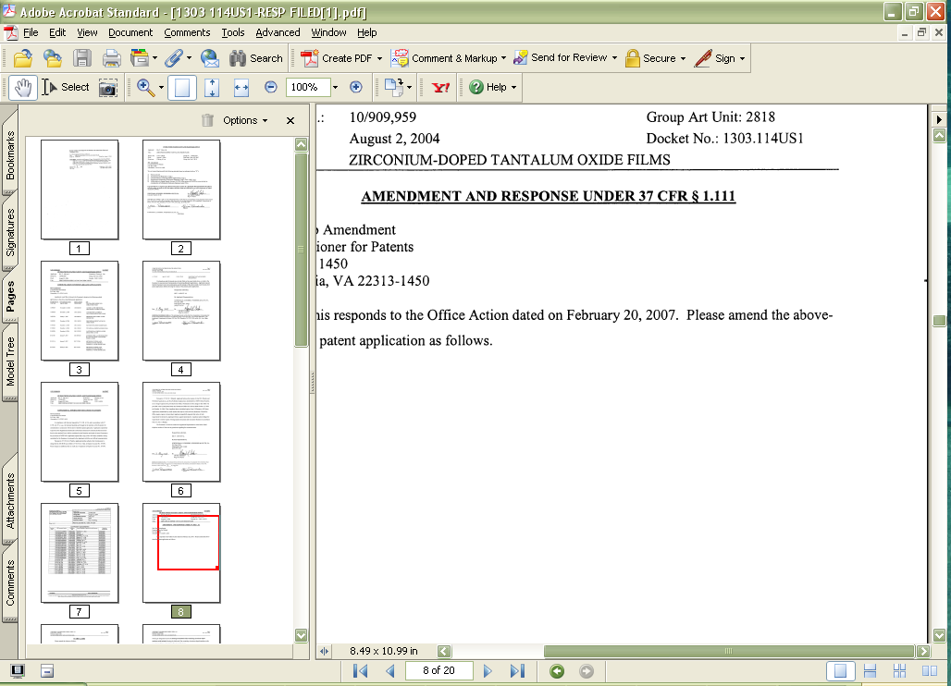

The last page contains an attorney signature block. A “Notice of References Cited” document (not shown below) following the signature can remain in the saved office action or notice of allowance PDF.
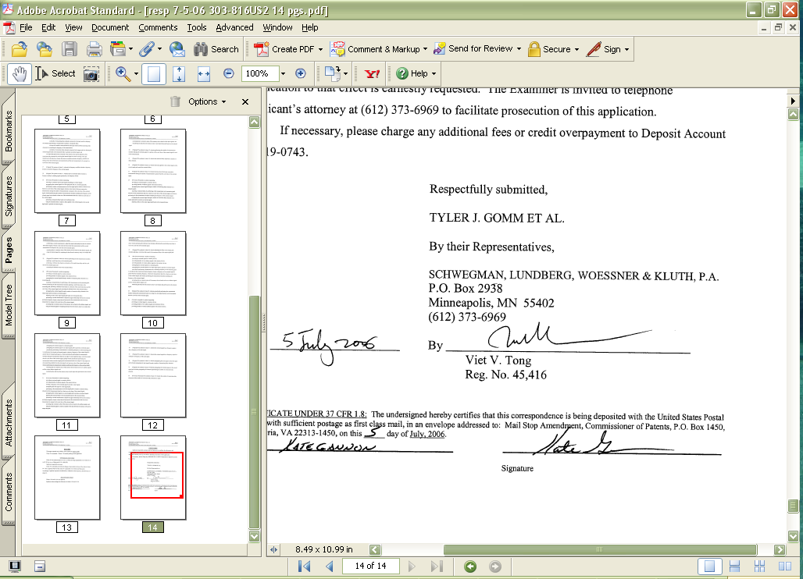

Resave the PDF file using the above format described in Instruction Number 5.

Upload this new file to the Response reference (note new number of pages).
FOREIGN OFFICE ACTION/SEARCH REPORT INSTRUCTIONS
- Find the prosecution history for the matter you are working to update
  - To do this either
    - Examine/print the activity screen for the matter in FIP
    - Look here for information on EP and some other European matters
    - Look here for information on PCT matters
- Identify all relevant actions to upload as references using the list below <Make sure you are not re-entering references already in FIP>
- Anything involving “Search Report”

  - International Search Report
  - Preliminary Search Report
  - Supplemental Search Report
  - Examiner’s Search Report

- Anything involving an “Office Action”

  - International Preliminary Report on Patentability
  - International Preliminary Examination Report
  - Examiner’s Action
  - First action
  - Office Action

- Anything involving responses to Office Actions or amendments

  - Response to first office action
  - Amendment and response

- Please note that because each country uses slightly different terms we cannot provide a full list of what needs to be upload. Please use the list above as a guideline not a definitive list.
- Open each activity to be uploaded as a Prosecution Document open, strip, and save the PDF to be uploaded as a reference attachment.
  - Strip the Document of excess pages.
    - Make sure to remove any communication from the foreign representative directed to us. Also make sure to remove any section with “comments” on the search report or Office Action.
  - When saving PDFs, use the following name format: [Matter number]_[CODE]_[Date].
    - Example 2050001EP1_OARN_01-05-07.
    - It is important not to use any slashes, periods, commas, parenthesis, or quotes in the name.
  - If available please include a translation of the office action or response.
    - This can be a bit complicated. Translations are often not received at the same time as the action or response. Also we frequently receive only partial translations. Please include, with the original document, as much of a translation that is available.
- Go to the References Screen and have FIP show “All References”.
  - Make sure you are in the matter the office action originated in. Always enter foreign office actions into the foreign matter that they originated in.
- Add Each New Reference: See Separate Instructions.
- After completing a matter (if you did a full review), enter comment in matter management: “All office actions and search reports entered as references as of [date completed] – YOUR INITIALS HERE”
  - If you did a full review and there are no references, enter comment in matter management: “Matter reviewed [date reviewed] - no office actions or search reports found – YOUR INITIALS HERE”
- Move on to the next requested matter.
ADD EACH NEW REFERENCE
- Title: Application Serial No. first, then the title of the item, then mailing date,
- Correct Title format when adding new reference: (Not all possible titles listed; use these as guides)
  - Office Actions: “[Country Name] Application Serial No. [Serial No], Final Office Action mailed 03-13-05”
    - For country name use Chinese, European, German, International (for PCT) etc.
  - International Search Report: International Application Serial No. PCT/US2007/017992, International Search Report mailed 07-13-05
  - International Written Opinion: International Application Serial No. PCT/US2007/017992, Written Opinion mailed 07-13-05
  - Response to Office Action: European Application Serial No 1234567, Response filed 01-01-01 to Office Action mailed 09-01-00
- Ref. Pages: Enter total number of pages of the stripped document here (i.e. “5 pgs”). Amendments, Responses should be stripped down to remove all additional documents like communications from the foreign associate, bills from the foreign associate, extensions of times, postcards, transmittals, etc., and the pages re-counted.
- Source Date: For office actions and notices of allowance this will be the date mailed. For amendments/responses, use the filing date of the response.
- Source Description:
- If available select the appropriate option from the dropdown list.
- If not select “Other” and enter into the box below “[Country Name] Office Action” or “[Country Name] Examiner’s report”
- Cite/Received From PTO Date - it is very important that all prosecution documents entered are “marked” in the source matter.
- Some source descriptions from the dropdown menu (PCT Search Report, and PCT Written Opinion) auto fill the “Received from PTO” date. Others don’t so please check.
    - If the date does not auto fill please Click “Received from PTO and enter the source date into the corresponding box.
- Any document we filed (all responses and amendments) will require the date to be entered manually. Click on Cited/Sent, check Cited, enter cited date (the date the amendment was filed), check Sent, and put the same date in that box (see separate sheet).
- Upload the appropriate document as an attachment as follows:
- Click “Browse”
- Click the correct file.
- Select OK.
- Click “Save”
How to strip a foreign office action or foreign response
Open the PDF file, identify the first page of the actual office action or response, and delete all pages that are not part of the office action or response. The first several pages are frequently communication from the foreign associate and should be deleted (for example see below).

Notice the top line is the name of a law firm. This is communication from the foreign associate and must be deleted.
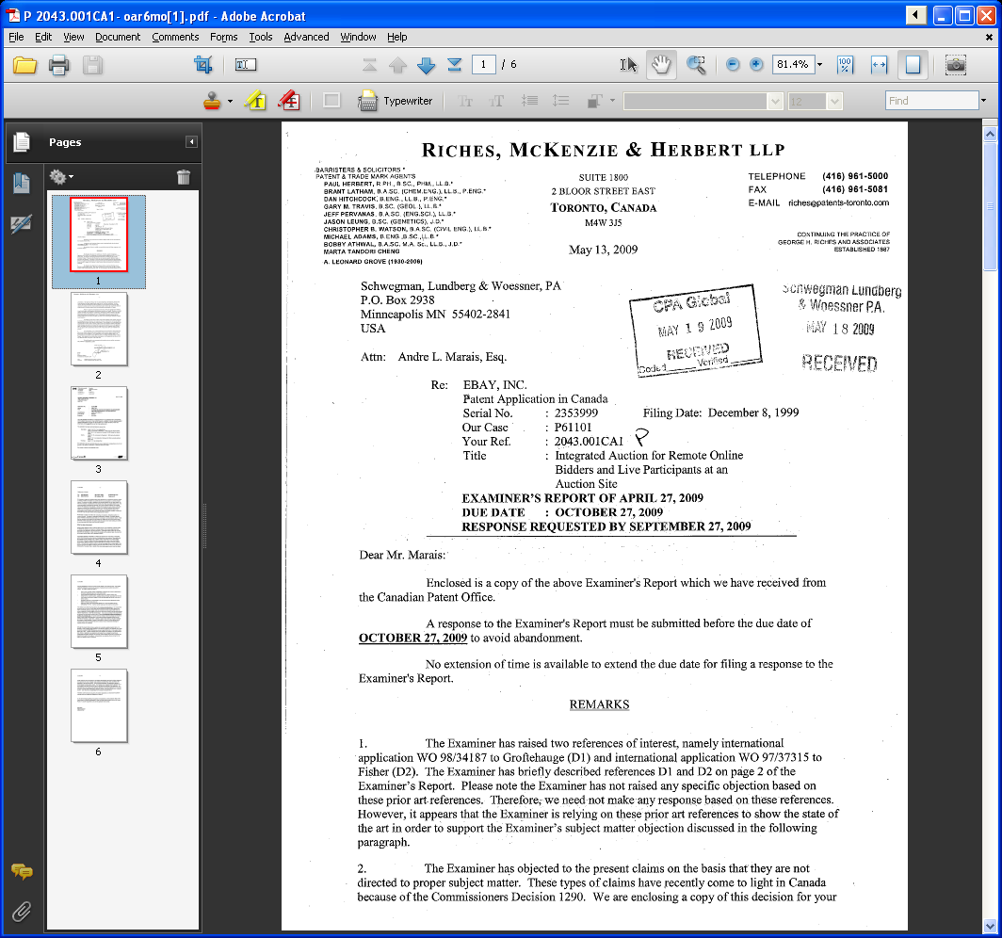
In this example we are stripping an office action. This is the first page of the actual office action. Notice the flag and the “Canadian Intellectual Property Office at the top”. In almost all cases you will find these or similar indications of the first page of the actual office action.
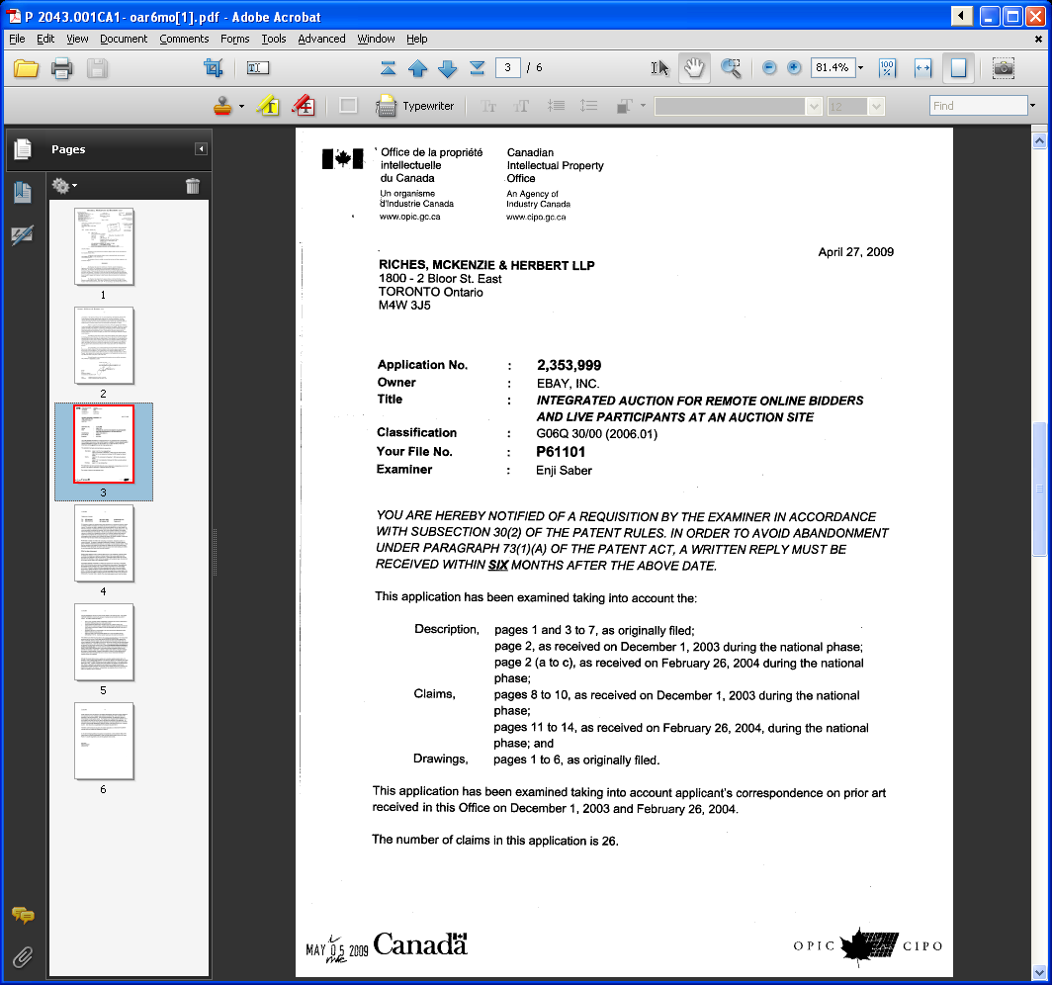
For some countries the divide is not so clear. For instance this (see below) is clearly from a foreign associate.
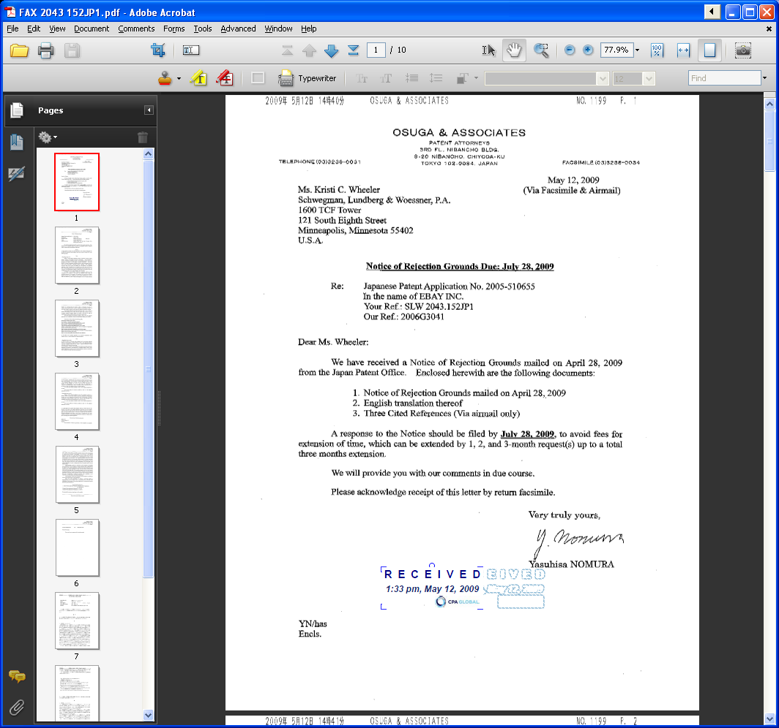

But because this is a translation the first page of the office action is not nearly as formal and official looking. This also frequently applies to foreign office action responses.
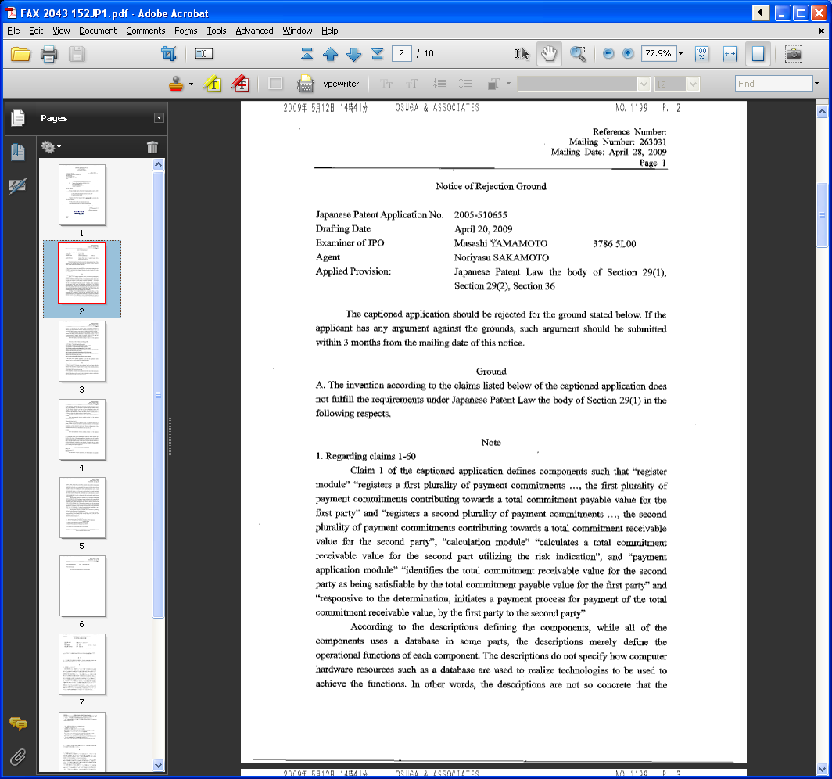

Also, in cases where a translation is included make sure to include the translation and the original document (first page of original below).
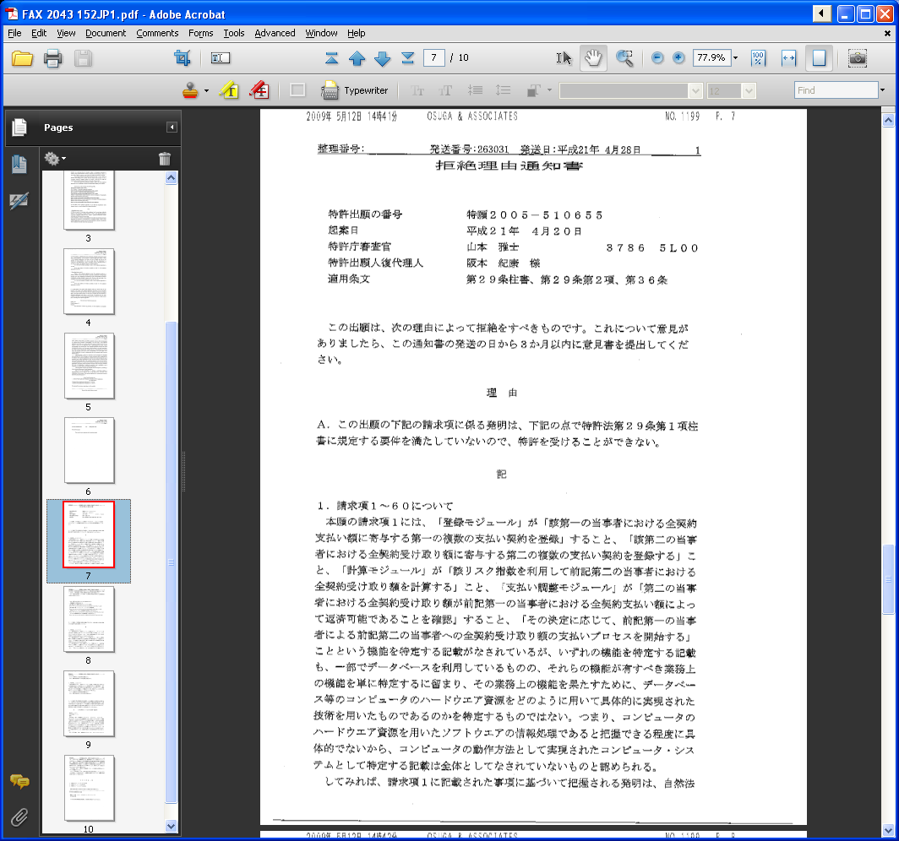

US Unpublished or Provisional Applications
- Identify all references to be added
  - Citing unpublished applications is sometimes necessary, however, please search first (Private Pair is a good place to look) to see if the application has published or issued. If it has published please cite the published app. If it has issued please cite the issued patent.
- Locate all available information about the unpublished or provisional application
  - Searching Private Pair is often useful as you can find filing date, inventor, and title listed.
- Locate a copy of each unpublished or provisional application
  - If copies are not provided check private pair to see if the application can be accessed.
  - If you are unable to locate a copy add the reference to FIP and then notify the assigned IDS specialist.
- Search in FIP to make sure the application has not previously been entered as a reference
- Enter all appropriate information
  - Author: List the first named inventor. If there are more than one inventor check the “et al.” box
  - Title: List the title of the invention in all caps
  - Citation: Enter “US Application Serial No. <SERIAL NUMBER HERE>, Filed <FILING DATE HERE>
  - Ref. Pages: List the number of pages here
  - Publication date: Leave this blank
  - Attachment - Select the PDF of the unpublished application
- Examples (search in the IDS manager)
  - Ref ID# 348446
  - Ref ID# 173691
Web Pages as References
- Identify all references to be added
- Go to the web page you are to add as a reference
- Print the web page to Adobe PDF
  - Make sure the page is properly printed and is not missing any elements
- Search in FIP to make sure the reference has not previously been entered
- Enter all appropriate information
  - Author: For many websites (like eBay or Wikipedia) this will be blank. If, however, the reference is an article or site written by one or more listed people please fill in this field.
  - Title: For the title of a website you need to decide what is the most prominent and unique aspect of the site and use that as the title. Usually the header (top left of a printed website) works well. Please don’t be so general as to simply put Wikipedia.com. If the reference you are citing is a home page please put that, “Wikipedia.com: Home Page”.
  - Citation: Usually this box will be left empty for websites. If there is any secondary information that you feel is relevant put it here. DO NOT put the web address in this box.
  - Misc. Info.: Put the web address here in this format: [Online]. Retrieved from the Internet: <URL: WEB ADDRESS GOES HERE>
  - Ref. Pages: Put the page count here
  - Publication date: If the reference you are adding was published on a specific date and that date is listed put that here. Usually that is not the case. If this is a general website (eBay or Wikipedia) find the date that the site was accessed (if it was printed out this is usually on the bottom right). List that date but precede it by the word “accessed”. This is important as we are not saying that is the date the site was published but the date we accessed it on
  - Attachment - Select the printed PDF of the website
- Examples (Search in the IDS manager)
  - Website with an author and date - Ref ID# 446162
  - Website no author no date - Ref ID# 452626
Journal Articles and other Scholarly Work
- Identify all references to be added
- Locate a copy of the article to be added as a reference
  - If copies are not provided do a quick internet search to see if the work is freely available.
  - If you are unable to locate a copy add the reference to FIP and then notify the assigned IDS specialist or Anne Koch.
  - If you are unable to locate the information needed to enter the article please contact the assigned IDS specialist or Anne Koch
- Search in FIP to make sure the reference has not previously been entered
  - This is very important. It is especially important with journal articles as it is very easy to add a duplicate reference to FIP.
- Enter all appropriate information
  - Author: The author of the article. If there is more than one author list the first one and then check the “et al.” box
  - Title: The title of the article.
  - Citation: First list the journal or conference that the article was published in or appeared at. Then, if applicable, list the volume and issue number either like “Vol. 2, No. 5” or “2 (5)”
  - Misc. Info.: If the article was retrieved online out the web address here in this format, [Online]. Retrieved from the Internet: <URL: WEB ADDRESS GOES HERE>
  - Ref. Pages: If possible list the pages the article appeared on here. If not possible list the number of pages.
  - Publication date: The publication date must be listed. Year is sufficient but if a more specific date is available please list that. For conference simply list the first date.
- Examples (Search in the IDS manager)
  - Journal Article - Ref ID# 168316
  - Thesis - Ref ID# 430061
Books and chapters of books
- Identify all references to be added
- Locate a copy of the book or the chapter to be cited
  - If a copy is not provided ask the person that requested the references to be added or attorney if one is available.
  - If you are unable to locate a copy add the reference to FIP and then notify the assigned IDS specialist or Anne Koch.
- Search in FIP to make sure the reference has not previously been entered
- Enter all appropriate information
  - Author: The author of the book/section. If there is more than one author list the first one and then check the “et al.” box
  - Title: If you are citing the entire book leave this blank. If you are only citing one section (chapter or sub-chapter) list the title of the section.
  - Citation: List the title of the book here.
  - Misc. Info.: List the name of the publisher here.
  - Ref. Pages: If you are citing an entire book list the page count. If you are citing a section of the book list the pages for that section.
  - Publication date: The year the book was published
- Examples (Search in the IDS manager)
  - Whole book - Ref ID# 425120
  - Section of a book - Ref ID# 293421
Court Document
- Identify all references to be added
- Locate a copy of the document to be added
  - If a copy is not provided ask the person that requested the references to be added or attorney if one is available.
  - If you are unable to locate a copy add the reference to FIP and then notify the assigned IDS specialist or Anne Koch.
- Search in FIP to make sure the reference has not previously been entered
- Enter all appropriate information
  - Author: This section will be left blank for court documents
  - Title: Enter the title of the document.
    - Example: “Continued Deposition of Nicholas Joseph Magliato”
  - Citation: List the plaintiff and defendant, the case number and the location of the trial.
    - Example “MercExchange, L.L.C. v. eBay Inc., and Returnbuy, Inc., United States District Court Eastern District of Virginia Norfolk Division, Civil Action No. 2:01-CV-736”
  - Misc. Info.: This space will usually be blank but sometimes can you used for extra info (see the second example below)
  - Ref. Pages: List the page total of the document. If the pages are specifically numbered list the numbers of the pages.
  - Publication date: The date of the court proceedings
- Examples (Search in the IDS manager)
  - Ref ID# 298151
  - Ref ID# 463001
Video
- Identify all references to be added
- Locate or go to (if online) the video you are to add as a reference
- Search in FIP to make sure the reference has not previously been entered
- Enter all appropriate information
  - Author: For many videos this will be blank. If, however, the video has a stated author/creator please fill in this field.
  - Title: If the video has a specific title please use that. However, for many videos you will need to decide what is the most prominent and unique aspect of the video and use that as the title. Following the title please put “[Video]”.
  - Citation: Usually this box will usually be left empty for videos. If there is any secondary information that you feel is relevant put it here. DO NOT put the web address in this box.
  - Misc. Info.: Put the web address here in this format: [Online]. Retrieved from the Internet: <URL: WEB ADDRESS GOES HERE>
  - Ref. Pages: Please list the length of the video.
  - Publication date: If the reference you are adding was published on a specific date and that date is listed put that here. Usually that is not the case. Otherwise find the date that the video was accessed and list that date but precede it by the word “accessed”. This is important as we are not saying that is the date the site was published but the date we accessed it on
  - Attachment – If possible please upload the video to FIP. If the video is larger than 25 MB it will probably not fit in FIP. In that case please store the video on the Z: drive please note where you put it in “Additional Comments”.
- Examples (Search in the IDS manager)
  - Ref ID# 479574
Overview of Marking References
The reference section of FIP fulfills two main purposes. The first is to keep track of all of the references that we have copies of and information on. The second purpose is to keep track of which references have been cited (or not cited) in certain matters. It is very important to enter references correctly as well as mark references correctly.
When references are entered into FIP they may be entered as either “Marked” or “Unmarked”. They should only be entered as “Marked” if they were cited or if they were received from the PTO in the matter that they are being entered into. A reference that was entered into one matter as marked that then flows into another matter should not be marked in that second matter unless it was also cited or received from the PTO there as well.
There are 4 possible ways a reference can be marked.

“Unmarked”
The first way a reference can be entered is as “Unmarked”. This typically happens when an attorney or client provides us references to be cited in a specific matter. For these references simply enter the reference and do not check or change any of the marked boxes. Reference can also be entered as “Unmarked” when they are added to one matter as “Marked” but then flow into another matter. This is ok. Do not follow those references into other matters and mark them. Only mark references in the matters that you are specifically working on. References entered as “Unmarked” will remain unmarked until they are cited by us to the PTO or by the PTO back to us.
Do not change any reference from “Marked” to “Unmarked” unless specifically instructed. This should almost never happen.

“Marked Cited and Sent”
The second way a reference can be “Marked” is “Marked – Cited and Sent”. This means that that reference was sent to the patent office and cited in that matter. References that are entered off of 1449s (IDS and SIDS) or from the front page of a patent should be marked as “Marked - Cited and Sent”
For example, imagine that you are entering references into matter 1.001US1 which is a transferred in matter. In 1.001US1 a few SIDS were filed by the previous firm. All references from those SIDS need to be entered into the matter that you are working on (1.001US1) and “Marked – Cited and Sent”. You do this by checking the check boxes for “Cited/Sent”, “Cited Date” and “Sent Date” and entering the date of the SIDS into the “Cited Date” and “Sent Date” field at the time of entering. Or if the reference already exists in the matter you are working on you can mark them in bulk by checking multiple references on the references screen and then selecting “Mark as Cited”. Make sure to fill in the correct date for the SIDS in the appropriate field. However, it is important to only mark reference in the matters in which they are actually cited. In my example there are many references to enter into matter 1.001US1. All of them need to be marked as “Cited and Sent”. All of those references will flow into related matter 1.001US2. In this example we need to leave the references in 1.001US2 as “Unmarked” because they have not yet been cited in that matter (1.001US2).

“Marked Received from PTO”
The third way a reference can be marked is “Marked – Received from PTO”. This means that the reference was cited to us by the PTO. These references are often entered from office actions, prosecution documents, search reports, and other documents received from the PTO. It is very important that these references only be marked in the matters in which they were received.
For example, imagine that you have received a non-final office action in matter 1.001US1. Within that office action the examiner cited one reference “John, Doe How the Internet works, 2012”. When you add that reference you need to make sure to check the box for “Received from PTO” and enter the date of the office action. That will mark the reference in matter 1.001US1 as “Received from PTO”. However, when that same reference flows into related matter 1.001US2 it should be left as “Unmarked. That is because it has not been cited or received yet in that matter (1.001US2).

“Marked Do Not Cite”
The last way a reference can be marked is “Marked – Do Not Cite”. Do not mark references as “Do Not Cite”. This should only be done by IDS staff or attorneys and is only done after a review of the reference.

